Software Process Models

A software process model is a simplified representation of a software process. Each model represents a process from a specific perspective.

Waterfall Model:
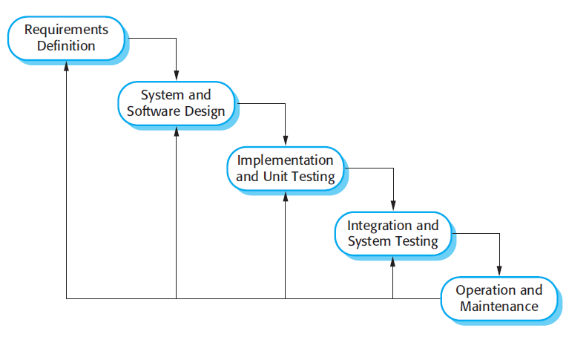
The Waterfall Model was first Process Model to be introduced. Each phase must be completed before the next phase can begin and there is no overlapping in the phases.The outcome of one phase acts as the input for the next phase sequentially.The waterfall model is a sequential design process in which progress is seen as flowing steadily downwards.it is also referred to as a Linear-Sequential Life Cycle Model.
Requirements Definition:
The specifications of the input and output or the final product are studied and marked.
System and software Design:
It helps in specifying hardware and system requirements and also helps in defining overall system architecture.The software code to be written in the next stage is created now.
Implementation and unit testing:
With inputs from system and software design, the system is first developed in small programs called units, which are integrated in the next phase. Each unit is developed and tested for its functionality which is referred to as Unit Testing.
Integration and testing:
All the units developed in the implementation phase are integrated into a system after testing of each unit. The software designed, needs to go through constant software testing to find out if there are any flaw or errors.
Operation and Maintenance:
Once the functional and non-functional testing is done, the product is deployed in the customer environment .Maintainence involves modification.These modifications arise either due to change requests initiated by the customer, or defects uncovered during live use of the system. Client is provided with regular maintenance and support for the developed software.

Iterative Waterfall model:
In a practical software development project, the classical waterfall model is hard to use.So, Iterative waterfall model can be thought of as incorporating the necessary changes to the classical waterfall model to make it usable in practical software development projects.
- The iterative waterfall model provides feedback paths from every phase to its preceding phases, which is the main difference from the classical waterfall model.

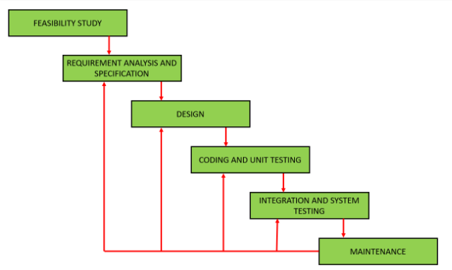
When errors are detected at some later phase, these feedback path allow the phase to be reworked in which errors are committed and these changes are reflected in the later phases. Feasibility study has no feedback because once the project is taken should not give up easily.
Advantages of Iterative Waterfall Model:
- Feedback path:It gives chance for error correction.
- Simple:Easy to understand and use.
Drawbacks of Iteratie Waterfall Model:
- Difficult to incorporate change requests.
- Incremental delivery not supported.
- Overlapping of phases not support.
- Risk handling not supported.
- Limited customer interactions:Starting and ending stage of process only.

Agile Process Model:
Agile processes generally promote a disciplined project management process that encourages frequent inspection and adaptation, a leadership philosophy that encourages teamwork, self-organization and accountability, a set of engineering best practices intended to allow for rapid delivery of high-quality software.
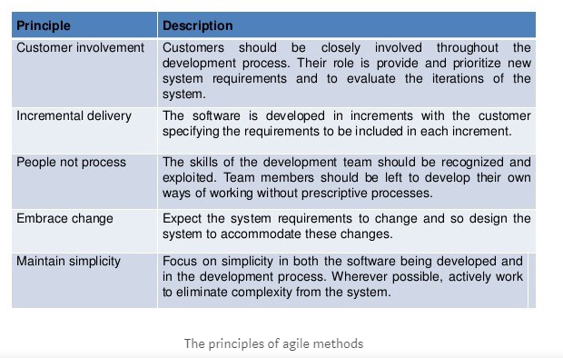
There are different agile methods like SCRUM, Extreme Programming etc. The most popular method is Scrum. Scrum is a subset of Agile. It is a lightweight process framework for agile development, and the most widely-used one.
The actors in Scrum are:
- Product Owner (PO)
- Scrum master
- Team
Product Owner:
- PO should have a vision of what to build, and convey that vision to the scrum team.
- PO is one who creates the product backlog.Product backlog has all the feature details in the form of stories .
- PO prioritize the stories as per the requirement, and those are taken in the sprint accordingly.
Scrum Master:
- The ScrumMaster is responsible for making sure a Scrum team lives by the values and practices of Scrum.
- The ScrumMaster does facilitating meetings, and doing things like working with the product owner to make sure the product backlog is in good shape and ready for the next sprint.

Scrum Team:
- Scrum teams are cross-functional, including the skills of software engineers, architects, programmers, analysts, QA experts, testers, UI designers, etc.

Sprint:
All the activities are carried out in the form of sprints. Sprint period can be defined as 1 month, 2 weeks or 1 week. Depending on the sprint period, the features or functionality are taken up in the sprint.
Sprint Planning:
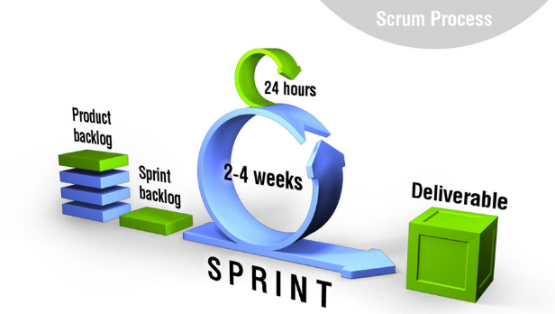
PO, Scrum master and Team all three are the part of the sprint planning.This happens on the first day of the sprint.The story is breakdown into tasks like test case writing, test case review, Updating test case, test case execution, bug retesting etc , and is allocated to the team members.Each tasks has its hour allocation. Once completed, hours are logged against that task with proper comments.
During The Sprint :
Development and QA start their work.Once development is done,QA`s perform functional testing.Bugs are raised accordingly.Developers resolves the bugs,those are retested by QA`s.Once all the story acceptance criteria are met, QA’s mark it as approved state.PO re-verifies it, and accordingly either closes or reopens the story.All these activities are traced by scrum master and team during their daily standup.In stand up meeting all meet and discuss on what task they worked yesterday, on what they are working today and if team has any blockers. Scrum master is responsible for resolving the blockers and solving the team queries. If team is unable to finish 1 or 2 stories,they are moved to next sprint.
Sprint Demo:
PO, scrum master, team and other stakeholders are the part of sprint demo. Team is asked to showcase the features they have developed in the sprint during sprint demo.If any changes required,they develop in the next sprint.This is done on the last day of the sprint.

Sprint Retrospective:
In this meeting, scrum master and team discuss what went wrong in the sprint, what new things we can try in order to achieve the best and on time delivery.
Agile Benefits:
- Customer satisfaction.
- High product quality.
- Increased project control.
- Reduced risks.
Incremental process model:
It is also called successive version model.Few basic features of software product is built and it is delivered to the customer .Then thereafter many successive versions are implemented and delivered to the customer until the desired system is realized.
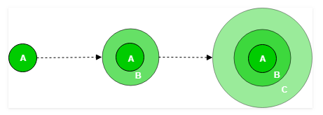
A, B, C are modules of Software Product that are incrementally developed and delivered.
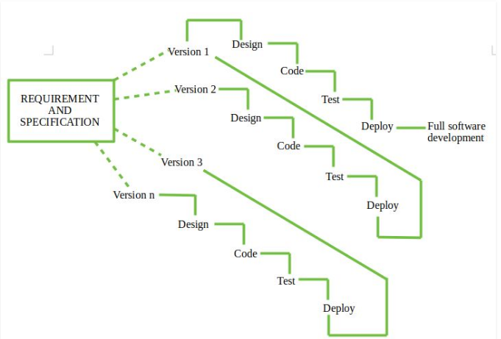
Development Team first undertakes to develop core features of the system. Once the core features are fully developed, then these are refined to increase levels of capabilities by adding new functions in Successive versions. Each incremental version is usually developed using an iterative waterfall model of development. As each successive version of the software is constructed and delivered, now the feedback of the Customer is to be taken and these were then incorporated in the next version.
Types of Incremental model :
- Staged Delivery Model .
- Parallel Development Model.
Staged Delivery Model – Construction of only one part of the project at a time.
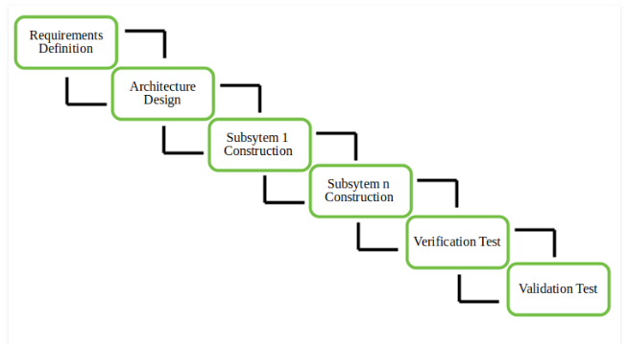
Parallel Development Model –Different subsystems are developed at the same time.Time consumption is less.
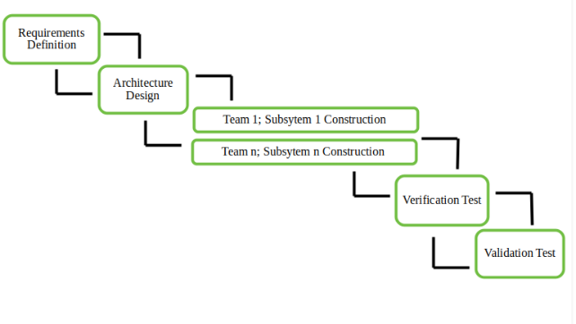

Advantages :
- Error Reduction.
- Incremental Resource Deployment.
Disadvantages :
- Requires good planning and design.
- Total cost is not lower.
Spiral Model:Spiral model provides support for Risk Handling. Below diagram looks like a spiral with many loops.The exact number of loops of the spiral is unknown and can vary from project to project.Each loop of the spiral is called a Phase of the software development process.

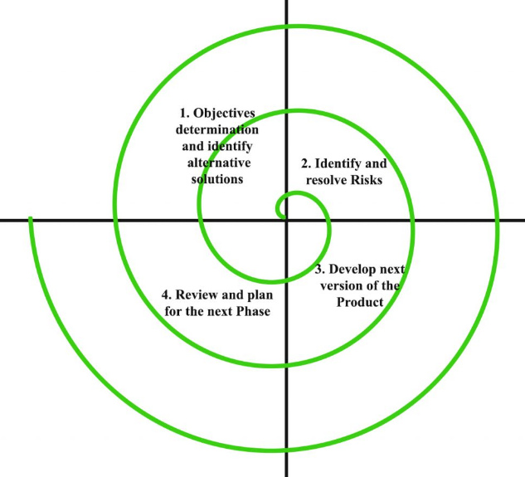
The Radius of the spiral at any point represents the expenses(cost) of the project so far, and the angular dimension represents the progress made so far in the current phase.
- Objectives determination and identify alternative solutions :Requirements are gathered and objectives are identified, elaborated and analyzed at the start of every phase.Then alternative solutions possible for the phase are proposed in this quadrant.
- Identify and resolve Risks: All the possible solutions are evaluated to select the best possible solution. Then the risks associated with that solution is identified and the risks are resolved using the best possible strategy. At the end Prototype is built.
- Develop next version of the Product: Developed features are verified through testing.At the end next version of software is available.
- Review and plan for the next Phase: The Customers evaluate the so far developed version of the software. In the end, planning for the next phase is started.

Risk Handling in Spiral Model :The unknown risks after the project has started are easier done by developing a prototype.The features of the product dated and analyzed and the risks at that point of time are identified and are resolved through prototyping.
Advantages of Spiral Model:
- Can handle risks easily.
- Good for large projects .
- Flexibility in requirement changes.
- Customer Satisfaction .
Disdvantages of Spiral Model :
- Complex .
- Expensive .
- Highly experienced expertise to develop a project using this model.
- Difficulty in time management.

